# INTRODUCTION

### Company Profile Overview

**Gateway Software Solutions**, based in Coimbatore, is a rapidly growing and credible name in the fields of software development and corporate training. With a team of seasoned professionals from both industry and academia,

We deliver end-to-end software development solutions and offer comprehensive training services tailored to meet the evolving needs of the IT industry. As a strategic partner in People Consulting and Talent Hiring, we provide quality-driven business solutions to empower organizations and individuals alike.

In collaboration with 4s Training Entity, the training division of Poras Technologies India Pvt Ltd, established in 2008, we extend our reach by offering specialized IT training programs. 4s Training Entity was founded on the belief that education is the foundation of hope and lifelong success.

Focused on bridging the talent gap in the IT sector, the organization delivers industry- relevant, future-ready training solutions to individuals, corporate, and academic institutions. Our courses are aligned with current technologies, practical in nature, and designed to help learners pursue globally recognized certifications.

Together, Gateway Software Solutions and 4s Training Entity are committed to driving innovation, enhancing employability, and shaping careers through technology and education.

### Vision and Mission

**VISION:** Vision is to establish ourselves as a leading solution provider in the IT industry, driving innovation and setting new benchmarks. We are deeply committed to delivering high- quality outcomes while also nurturing talent by developing skilled, industry-ready professionals aligned with the evolving demands of the IT sector.

**MISSION:** Mission is to deliver innovative and effective digital solutions that empower businesses to reach their full potential. By prioritizing quality above all else, we ensure not only success but also a solid, lasting foundation for strong client relationships. We are committed to understanding our clients’ goals and working collaboratively to provide tailored technical services that truly make a difference.

### Services and Products

Gateway Software Solutions offers a wide range of services and products, including payment gateways, system integration, financial services, POS solutions, cloud services, and software development. They also provide training programs and placement assistance.

#### SERVICES:

* + - Payment Gateway Development
    - System Integration
    - Financial Services
    - POS Solutions
    - Cloud Services
    - Software Development
    - Digital Marketing
    - Software Testing
    - Corporate Training
    - Placement Training
    - Summer Internships

#### PRODUCTS:

* + - Payment Gateways
    - POS Systems
    - ERP, CRM, HRM Systems
    - Web Applications
    - Software and Applications
    - Cloud Infrastructure

### Organizational Structure

* + - **Website :** [**http://gatewaysoftwaresolutions.com/**](https://www.linkedin.com/redir/redirect?url=http%3A%2F%2Fgatewaysoftwaresolutions%2Ecom%2F&urlhash=eozw&trk=about_website)
    - **Industry :** IT Services and IT Consulting
    - **Company size :** 11-50 employees
    - **Headquarters :** Coimbatore, Tamil Nadu
    - **Type :** Partnership
    - **Founded** 2015
    - **Specialties :** Corporate Training, Software Training, Certificate Courses, Certified Training, Software Courses, IT Training, IT Courses, Placement Training, Placement Courses, Skill Set training, Skill Set Courses, Internship Training, Internship, Engineering Students Project, Certificate Training, IEEE projects, MCA/MBA Project, HR internship, HR Intern, and Final year Intern.

# INTERNSHIP OBJECTIVES

##### Purpose of the Internship

The purpose of an internship in a paragraph is to provide an opportunity for students or individuals to gain practical experience in a specific field, allowing them to apply their academic knowledge to real-world situations.

Internships help interns develop valuable skills, enhance their understanding of the industry, and build professional networks. They also offer a chance to explore career interests, refine goals, and improve employability by gaining hands-on experience that makes them more competitive in the job market. Additionally, internships often allow employers to assess potential future hires, creating a mutually beneficial arrangement.

The internship is intended to be a vital link between academic learning and professional experience. Its main goal is to immerse me in a real-world work environment where I can apply theoretical concepts to address practical industry problems. By engaging in hands-on projects, the internship helps close the gap between classroom education and on-the-job application.

This opportunity will provide me with a clear insight into how businesses function on a daily basis, including the responsibilities, expectations, and problem-solving strategies typical in professional roles. It will enhance my technical skills and foster a mindset geared toward lifelong learning and adaptability. Overall, the experience is expected to provide a solid foundation for a seamless shift into a full-time career after graduation.

### Learning Goals

The internship experience is guided by several core learning objectives, each aimed at supporting both personal and professional development:

##### Proficiency in Industry-Relevant Tools and Technologies

A key objective is to gain practical exposure to the tools, software, and technologies that are prevalent in the professional world. While academic study lays the groundwork in theory, this internship will allow me to work directly with industry-standard platforms, helping me build technical expertise and stay up to date with current advancements.

##### Strengthening of Analytical and Problem-Solving Abilities

Participating in real-world assignments will sharpen my critical thinking and enable me to approach challenges with logical, data-informed solutions. Contributing to decision-making, troubleshooting issues, and completing tasks will teach me how to assess situations from different angles and develop effective responses.

##### Growth of Interpersonal and Communication Skills

Technical skills alone are not enough in a professional setting. This internship offers the opportunity to develop essential soft skills like communication, teamwork, and adaptability. Collaborating with experienced colleagues will provide insights into team dynamics, task coordination, and how to articulate ideas clearly and professionally.

##### Understanding of Workplace Culture and Professional Etiquette

Another important goal is to become familiar with the standards of conduct and ethical practices expected in the workplace. I aim to learn about professional behavior, time management, workplace discipline, and the respect required for organizational structures and procedures. Observing how projects are coordinated and goals are met will deepen my understanding of how businesses operate effectively.

##### Preparation for Future Career Pathways

This internship will act as a stepping stone toward my long-term career, offering firsthand experience of real work environments and professional expectations. Gaining insights into organizational roles, performance evaluation processes, and workplace hierarchies will help me make better-informed career choices. Additionally, building relationships with professionals in the field may lead to mentorship and future job opportunities.

# INTERNSHIP SCHEDULE

### Day-wise Activities Summary (Day 1 to 20)

#### DAY 1

##### Introduction to Backend

A backend developer plays a crucial role in the overall functionality and performance of a web application by focusing on the server-side architecture. In addition to building APIs, managing databases, and ensuring secure data flow, backend developers are responsible for designing efficient database structures and optimizing queries to handle large volumes of data. They implement essential security measures such as encryption, authentication protocols, and protection against common vulnerabilities to safeguard sensitive information. Backend developers also ensure the scalability and reliability of applications by using tools like caching systems, load balancers, and asynchronous processing methods. Their work often involves documenting APIs, writing automated tests, and maintaining clean, well-structured code that adheres to development best practices. They collaborate through version control systems like Git and contribute to deployment processes using CI/CD pipelines, containerization tools like Docker, and cloud platforms such as AWS or Azure. Additionally, backend developers are responsible for monitoring application performance, debugging issues, and performing regular updates to maintain system health. As technology continues to evolve, continuous learning and adaptation are essential aspects of the role, allowing backend developers to stay current with emerging frameworks, tools, and security standards.

#### DAY 2

##### Python

Python is a high-level, interpreted programming language known for its simplicity, readability, and versatility. Designed with a focus on code clarity, Python allows developers to write clear and logical code for both small and large-scale projects. Its clean syntax, which closely resembles plain English, makes it an ideal choice for beginners while still being powerful enough for advanced applications. Python supports multiple programming paradigms, including procedural, object-oriented, and functional programming. It is widely used in various domains such as web development, data science, machine learning, automation, and software engineering. With a large standard library and a vibrant community, Python offers countless modules and frameworks—such as Django, Flask, Pandas, NumPy, and Tensor Flow—that enhance its functionality and enable rapid development. Its cross-platform nature and ease of integration with other technologies make Python a dominant force in modern programming.

#### DAY 3

##### Strings in Python

In Python, a string is a sequence of characters enclosed in single, double, or triples quotes, used to represent text. Strings are immutable, meaning once created, they cannot be changed directly; any modification results in the creation of a new string. You can access individual characters using indexing, with 0 as the first position and negative numbers counting from the end. Python provides many built-in methods such as upper ( ), lower ( ), strip ( ), replace( ), and split(

) to manipulate and transform string data efficiently. Strings can be joined using the + operator (concatenation) or formatted using format ( ), % formatting, or f-strings, allowing dynamic insertion of variables into text. Additionally, strings support slicing to extract substrings and can be iterated character by character using loops. Python also allows checking for substrings using the in keyword and comparing strings lexicographically using comparison operators. With support for Unicode, strings in Python can represent text from multiple languages, making them ideal for modern, internationalized applications. These features make strings in Python both powerful and flexible for a wide range of text processing tasks.

#### DAY 4

##### Control Structure

Control structures in Python are fundamental components that manage the flow of a program based on certain conditions or repeated actions. They enable developers to write dynamic and flexible code by controlling the execution path depending on logical decisions. Python provides several types of control structures, including conditional statements (if, elif, else) for decision-making, loops (for, while) for executing code repeatedly, and loop control statements like break, continue, and pass to fine-tune loop behavior. These structures help in implementing logic such as branching, iteration, and handling exceptions. Python’s support for nested control structures allows complex decision-making processes within loops and conditions, making it suitable for building sophisticated programs. In addition, Python’s exception handling mechanisms (try, except, finally) function as an extended control structure, enabling developers to manage errors gracefully and maintain application stability. The clarity and indentation-based syntax of Python enhance the readability of control flows, reducing the chances of logic errors and making code easier to debug and maintain. Overall, control structures form the backbone of any Python application, providing the necessary tools to build logical, adaptable, and user-responsive software.

#### DAY 5

##### Function

In Python, a function is a reusable block of code designed to perform a specific task, improving modularity and code organization. Functions help reduce repetition by allowing programmers to define a set of instructions once and use it multiple times throughout a program.

In Python, functions are defined using the def keyword, followed by the function name and parentheses containing optional parameters. They can return values using the return statement or simply perform actions without returning anything. Python also supports built-in functions like print(), len(), and range(), as well as user-defined functions tailored to specific needs. Functions can take default arguments, variable-length arguments (*args and **kwargs), and even other functions as parameters, enabling powerful and flexible code structures. Additionally, Python supports anonymous functions using the lambda keyword for simple operations. By promoting reusability, readability, and ease of debugging, functions are a core component of Python programming and essential for writing clean, efficient, and scalable code.

#### DAY 6

##### Arguments

In Python, arguments are the values passed to functions when they are called, allowing functions to operate on different data inputs and produce dynamic results. Arguments are defined within the parentheses of a function’s definition and are used as variables inside the function body. Python supports several types of arguments, including positional arguments, which are matched by order; keyword arguments, which are matched by name; and default arguments, which allow functions to be called with fewer inputs by assigning default values. Additionally, Python allows functions to accept a variable number of arguments using *args for non-keyword variable arguments and **kwargs for keyword variable arguments, offering great flexibility. This versatility in handling arguments makes Python functions highly adaptable, enabling developers to write more general and reusable code that can handle a wide range of input scenarios efficiently.

#### DAY 7

##### SQL (Structured Query Language)

SQL (Structured Query Language) is a standardized programming language used to manage and manipulate relational databases. It allows users to perform a wide range of operations such as creating, retrieving, updating, and deleting data stored in tables. SQL is essential for working with databases, providing commands like SELECT, INSERT, UPDATE, DELETE, CREATE, and DROP to interact with database structures and their contents. One of the key strengths of SQL is its ability to query data efficiently using powerful filtering, sorting, grouping, and joining techniques. SQL is widely supported by various database systems such as MySQL, PostgreSQL, SQLite, and Microsoft SQL Server. Its clear syntax and declarative nature make it accessible to beginners while being robust enough for complex database operations in professional environments. Overall, SQL is a foundational tool for data management, analytics, and application development.

#### DAY 8

##### SQL Keys

In SQL, keys are essential components used to uniquely identify rows in a table and establish relationships between tables within a relational database. The most commonly used key is the primary key, which ensures that each record in a table is unique and not null. Another important key is the foreign key, which creates a link between two tables by referencing the primary key of another table, enabling relational integrity and structured data connections. Other types include unique keys, which prevent duplicate values in a column, and composite keys, which consist of two or more columns used together to uniquely identify a record. Keys play a crucial role in enforcing data integrity, optimizing queries, and maintaining the logical structure of a database. By properly defining and using keys, developers can ensure consistency, accuracy, and efficiency in data storage and retrieval.

#### DAY 9

##### Python SQL Connection

In Python, connecting to an SQL database is made simple and efficient through various libraries that facilitate communication between Python programs and relational databases. One of the most commonly used libraries is sqlite3, which comes built-in with Python and is ideal for lightweight, file-based databases. For more robust systems like MySQL, PostgreSQL, or SQL Server, external libraries such as mysql-connector-python, psycopg2, or pyodbc are used. These libraries allow developers to establish a connection to the database, execute SQL queries, retrieve results, and handle transactions directly from Python code. Typically, the process involves importing the appropriate library, connecting to the database using credentials, creating a cursor object to execute queries, and then committing or rolling back changes as needed. This integration of Python with SQL enables powerful data-driven applications, allowing seamless data manipulation, analysis, and automation within a single programming environment.

#### DAY 10

##### HTML (Hypertext Markup Language)

HTML (Hypertext Markup Language) is the standard language used to create and structure content on the web. It provides the basic building blocks for web pages by using a system of tags and elements to define various types of content, such as headings, paragraphs, links, images, tables, and forms. HTML is not a programming language but a markup language, meaning it describes the structure and layout of web content rather than providing logic or functionality. Each HTML document starts with a <!DOCTYPE html> declaration and is composed of nested elements like

<html>, <head>, and <body>, which organize the content and metadata. HTML works closely with CSS for styling and JavaScript for interactivity, forming the foundation of nearly all websites. Its simplicity, readability, and compatibility with all web browsers make HTML an essential skill

for anyone involved in web development or design. Over time, HTML has evolved with versions like HTML5, which introduced new semantic elements such as <header>, <footer>, <article>, and

<section> to enhance the clarity and accessibility of web content. It also supports embedding multimedia through <audio> and <video> tags, as well as improved form elements and APIs that make modern web applications more powerful and user-friendly.

#### DAY 11

##### HTML tags

HTML tags are the core components of HTML used to define and structure elements on a web page. Tags are enclosed in angle brackets—for example, <p> for a paragraph or <h1> for a main heading—and usually come in pairs: an opening tag (e.g., <p>) and a closing tag (e.g., </p>), with the content placed in between. Some tags, like <img> or <br>, are self-closing and do not require a closing tag. Each HTML tag serves a specific purpose, such as displaying text, creating links (<a>), inserting images (<img>), building lists (<ul>, <ol>, <li>), or structuring sections of a page (<div>, <section>). Tags can also include attributes, such as href in an anchor tag or src in an image tag, to provide additional information or functionality. HTML also includes semantic tags like <header>, <footer>, <article>, and <nav>, which help describe the role of content more clearly and improve accessibility and SEO. Additionally, tags such as <form>, <input>, and

<button> enable user interaction by collecting data through web forms. With the introduction of HTML5, many new tags were added to enhance multimedia support (like <audio> and <video>) and ensure better structuring of modern web applications. Understanding how and when to use these tags effectively is essential for creating well-structured, accessible, and visually engaging web pages that work seamlessly across different browsers and devices.

#### DAY 12

##### CSS (Cascading Style Sheets)

CSS (Cascading Style Sheets) is a stylesheet language used to control the presentation and layout of HTML elements on a web page. While HTML structures the content, CSS enhances its visual appearance by defining styles such as colors, fonts, spacing, alignment, and positioning. CSS allows developers to separate content from design, making web pages easier to maintain and more consistent across multiple pages. Styles can be applied inline, internally within an HTML document, or externally through a linked .css file. CSS supports powerful features like selectors, classes, IDs, and media queries, enabling responsive design that adapts to different screen sizes and devices. It also includes advanced styling capabilities such as animations, transitions, and flexbox/grid layouts. By providing precise control over visual elements, CSS plays a critical role in creating attractive, user-friendly, and professional web experiences. Moreover, CSS frameworks like Bootstrap and Tailwind CSS further simplify and speed up development by offering pre- designed components and utility classes. With the evolution of CSS3, modern web design has become more interactive and visually engaging, allowing for complex designs without relying heavily on JavaScript.

#### DAY 13

##### CSS box model

The CSS box model is a fundamental concept in web design that describes how elements are structured and spaced on a web page. Every HTML element is considered as a rectangular box composed of four layers: content, padding, border, and margin. The content is where text or images appear. Surrounding the content is the padding, which adds space inside the element, between the content and the border. The border wraps around the padding and content, and can be styled with different widths, colors, and patterns. Outside the border lies the margin, which creates space between the element and other neighboring elements. Understanding the box model is essential for precise layout control, alignment, and spacing in CSS. It ensures that designers can predict how changes to padding, borders, or margins affect the overall size and positioning of elements on a web page. Additionally, developers can use the box-sizing property to control whether padding and border are included in an element’s total width and height, helping to avoid unexpected layout shifts. Mastery of the box model allows for the creation of clean, responsive, and visually balanced web layouts.

#### DAY 14

##### Flexbox

Flexbox (short for Flexible Box Layout) is a powerful CSS layout model that makes it easier to design responsive and flexible web page layouts. When an element is assigned display: flex, it becomes a flex container, and its direct children become flex items. Flexbox allows developers to control the alignment, direction, spacing, and size of these items within the container, both horizontally and vertically, without using floats or complicated positioning. It provides properties like justify-content, align-items, and flex-wrap to manage the layout efficiently. Flexbox adapts to different screen sizes and content dimensions, making it ideal for building dynamic user interfaces, navigation bars, grids, and component layouts. Its simplicity and flexibility significantly reduce the need for complex CSS code, enabling more efficient and clean design practices in modern web development. Additionally, properties like flex-grow, flex-shrink, and flex-basis allow elements to grow, shrink, or maintain a base size based on available space, giving developers precise control over layout behavior. Flexbox also helps in maintaining consistent spacing and alignment even when the content or screen size changes, making it a cornerstone of responsive design.

#### DAY 15

##### Position in CSS

In CSS, the position property is used to control how elements are placed on a web page, giving developers fine-grained control over layout and design. It determines the positioning method of an element in relation to its normal flow or to other elements. There are several positioning values: static, which is the default and follows the normal document flow; relative, which positions an element relative to its original position; absolute, which positions it relative to the nearest positioned ancestor; fixed, which anchors the element to the viewport, keeping it in place even when the page is scrolled; and sticky, which toggles between relative and fixed based on the scroll position. By using properties like top, right, bottom, and left alongside position, developers can control exactly where elements appear on the page. Understanding CSS positioning is essential for creating layered layouts, dropdown menus, modals, sticky headers, and other interactive web components. Additionally, combining z-index with positioning allows developers to control the stacking order of overlapping elements, which is critical for building clean, user- friendly interfaces. Mastery of the position property enables precise element placement and a deeper understanding of how elements behave within various contexts on the page.

#### DAY 16

##### JavaScript

JavaScript is a high-level, dynamic programming language that is essential for creating interactive and engaging web experiences. It is primarily used to add behavior and functionality to web pages, allowing developers to implement features such as form validation, dynamic content updates, interactive maps, image sliders, and real-time data display without requiring a page reload. JavaScript runs directly in the browser, making it a client-side language, although it can also be used on the server side with environments like Node.js. It works seamlessly with HTML and CSS to enhance user interfaces and create responsive designs. JavaScript supports event- driven programming, object-oriented features, and asynchronous operations using callbacks, promises, and async/await. With the help of frameworks and libraries like React, Angular, and Vue, JavaScript has become a cornerstone of modern web development, powering everything from simple websites to complex web applications. Additionally, tools such as Webpack, Babel, and ESLint help optimize and streamline development workflows. As browsers and JavaScript engines continue to evolve, the language remains a critical skill for developers aiming to build fast, responsive, and feature-rich web experiences. JavaScript also plays a vital role in progressive web apps (PWAs) and single-page applications (SPAs), enabling smooth navigation and app-like performance. With its vast ecosystem and community support, JavaScript continues to grow as a versatile, powerful language that adapts to the ever-changing demands of modern software development.

#### DAY 17

##### Combinators

In CSS, combinators are special selectors that define relationships between elements, allowing developers to apply styles based on the structure and hierarchy of HTML. Combinators connect two or more selectors in a way that specifies how the elements relate to each other in the document tree. There are four main types of combinators: the descendant combinator (a space), which selects all elements that are nested inside a specified parent; the child combinator (>), which selects only direct children of a given element; the adjacent sibling combinator (+), which targets an element that immediately follows another; and the general sibling combinator (~), which selects all sibling elements that follow a specific element. By using combinators effectively, developers can write more precise and efficient CSS rules, targeting elements based on context without relying on excessive classes or IDs. This leads to cleaner, more maintainable stylesheets and greater control over page layout and design.

#### DAY 18

##### Grid

CSS Grid Layout, commonly known as Grid, is a powerful two-dimensional layout system in CSS that enables developers to design complex and responsive web page layouts with ease. Unlike Flexbox, which is primarily one-dimensional (either row or column), Grid allows for precise control over both rows and columns simultaneously. By defining a grid container using display: grid, developers can create structured layouts by specifying grid tracks with grid-template- rows and grid-template-columns. Elements inside the grid container can be positioned using properties like grid-row, grid-column, grid-area, and gap for spacing. Grid makes it easier to align items, create consistent spacing, and build responsive designs that adapt seamlessly to various screen sizes. It also supports features like implicit and explicit grids, auto-placement, and media query integration. With its clean syntax and powerful capabilities, CSS Grid has become a go-to tool for modern web layout design, offering both flexibility and precision.

#### DAY 19

##### Django

Django is a high-level, open-source web framework written in Python that enables rapid development of secure and maintainable web applications. Designed to promote clean and pragmatic design, Django follows the Model-View-Template (MVT) architectural pattern, helping developers organize code efficiently. It comes with a robust set of built-in features such as an ORM (Object-Relational Mapping) system, user authentication, form handling, an admin interface, and security tools to prevent common vulnerabilities like SQL injection and cross-site scripting. Django emphasizes reusability and the "don't repeat yourself" (DRY) principle, allowing developers to build scalable web applications with less code. It supports URL routing, middleware,

and integration with databases like SQLite, PostgreSQL, and MySQL. Django’s extensive documentation and active community make it a popular choice for both beginners and professionals working on anything from simple websites to complex, data-driven platforms.

Additionally, Django supports Restful API development through tools like Django REST Framework (DRF), making it ideal for building backend services for mobile and frontend applications. Its modular design also encourages the use of reusable apps, making it easier to manage large projects. With features like internationalization, caching, and testing frameworks, Django provides everything needed to build high-performance, production-ready web applications quickly and efficiently.

#### DAY 20

##### To develop a Django application

To begin working with Django, you first need to create a project, which serves as the central configuration for your web application. After installing Django with pip install django, you can create a new project using the command django-admin startproject project name, replacing project name with your desired name. This generates a directory containing key files like settings.py, urls.py, and manage.py. Once the project is created, navigate into the project directory using cd project name and create an application within the project by running python manage.py startapp appname, where appname is the name of your specific feature module (like blog, accounts, etc.).

To run the Django development server, use the command python manage.py runserver. This starts a local server, and the project can be accessed in a browser at [http://127.0.0.1:8000/.](http://127.0.0.1:8000/) However, before Django recognizes the app, you need to collaborate the app with the project by adding it to the INSTALLED_APPS list in the settings.py file of the project. Simply include the app name as a string, for example: 'appname',. This step officially registers the application within the project, allowing it to function with features like URL routing, models, views, and templates. Through these steps, Django enables modular and scalable web development by organizing code into reusable components.

### Query Resolution Session

A query resolution session is a focused discussion where learners get their doubts clarified and concepts explained, helping to strengthen understanding, clear confusion, and boost confidence through direct interaction with instructors in a supportive learning environment. These sessions encourage active participation and create a space where no question is too small, ensuring that individual concerns are addressed and learners stay on track. They also promote collaborative learning, as students often gain insights from questions raised by others, making the overall learning experience more effective and engaging.

# DEPARTMENT / TEAM OVERVIEW

### Information Technology (IT)

The Information Technology (IT) Department serves as the backbone of an organization’s digital operations, ensuring that all technological resources are effectively managed and aligned with business objectives. Its core responsibilities include maintaining and upgrading hardware and software infrastructure, safeguarding data through robust cybersecurity measures, and providing timely technical support to employees.

In addition to day-to-day maintenance, the IT Department actively contributes to strategic initiatives such as digital transformation, automation, and the adoption of cloud-based solutions. By facilitating seamless communication, optimizing workflows, and enabling data-driven decision-making, the IT team empowers all departments to perform efficiently. It also plays a key role in training staff on new technologies, managing user access and permissions, and ensuring compliance with industry standards.

The department is instrumental in implementing disaster recovery plans, ensuring business continuity in the face of unexpected disruptions. It manages IT budgets, evaluates emerging technologies, and partners with vendors to procure efficient and cost-effective solutions. Furthermore, the IT team plays a central role in developing and maintaining internal software applications tailored to organizational needs.

Through its continuous innovation, risk management, and cross-functional collaboration, the IT Department not only supports operational stability but also drives the organization toward sustained digital growth and competitiveness.

### Tools and Technology Used

The Information Technology (IT) field relies on a wide range of tools and technologies to manage infrastructure, support users, secure systems, and drive digital innovation. For infrastructure management, solutions like VMware and Microsoft Hyper-V are widely used for virtualization, while tools such as Solar Winds, PRTG, and Nagios help monitor networks and servers to ensure optimal performance. Cloud platforms including Microsoft Azure, Amazon Web Services (AWS), and Google Cloud provide scalable infrastructure and services, supported by cloud storage tools like One Drive and Google Drive for secure file sharing.

Cyber security is a major focus, with firewalls like Fortinet, endpoint protection from providers such as CrowdStrike and Symantec, and identity management tools like Azure Active Directory and Okta securing access to systems. SIEM tools such as Splunk help monitor and respond to security threats in real time.

Communication and collaboration are enhanced through platforms like Microsoft Teams, Zoom, Slack, and SharePoint, enabling efficient teamwork across hybrid and remote environments. In the realm of automation and DevOps, tools like Jenkins, Docker, Kubernetes, Terraform, and scripting languages like PowerShell and Python streamline workflows and infrastructure management. IT service management is supported by systems like ServiceNow, Jira Service Management, and Freshservice for handling support tickets and service requests. Additionally, data analytics tools such as Power BI and Tableau enable data-driven decision- making, while backup and recovery solutions like Veeam and Acronis ensure business continuity.

These technologies not only enhance operational reliability but also empower the IT department to be more proactive and strategic in its approach. By integrating automation and monitoring tools, IT teams can anticipate issues before they impact users, ensuring minimal downtime and a seamless digital experience. Furthermore, the adaptability of these tools supports the organization’s growth by allowing IT infrastructure to scale alongside evolving business needs. With continuous updates, integration capabilities, and strong vendor support, these tools enable the IT function to stay current with industry trends and best practices. Ultimately, this integrated technology landscape fosters agility, boosts productivity, and strengthens the organization’s ability to innovate and stay competitive in a rapidly changing digital world.

# PROJECT DETAILS

### Project Title

* + - **Abstract**

### FACE RECOGNITION ATTENDANCE SYSTEM

Attendance management is a vital aspect of educational institutions, playing a key role in tracking student engagement, monitoring academic performance, and maintaining classroom discipline. Traditional attendance methods, such as manual roll calls, are time-consuming and disrupt the flow of teaching. Although modern technologies like biometric and RFID-based systems have improved accuracy, they still require student interaction, often leading to queues and delays. This project proposes an innovative involuntary attendance system designed to operate passively and seamlessly during regular classes and examinations. By eliminating the need for manual input or physical identification, the system records attendance automatically without interrupting the learning process. The goal is to enhance classroom efficiency, reduce time wastage, and provide a non-intrusive solution for accurate, real-time attendance tracking.

##### Overview of the Project

Attendance is a vital component in the effective management of educational institutions. It allows for the monitoring of student engagement, supports academic tracking, and ensures that classes function smoothly. Both educators and students benefit from precise attendance records, making their accuracy and reliability essential. However, the conventional method of taking attendance—by calling out names or roll numbers—is often inefficient and time-consuming. This practice disrupts lessons, interrupts teaching momentum, and requires students to wait passively, often resulting in lost instructional time and reduced classroom productivity.

To overcome these issues, many institutions have adopted automated attendance technologies, such as biometric scanners or RFID-based systems. These solutions have improved the speed and precision of attendance recording. Nonetheless, they are not without limitations. Most notably, students still need to line up or wait their turn to be recognized by the system, which consumes time and can complicate classroom logistics—especially in institutions with large student populations, where long lines may cause delays and dissatisfaction.

To tackle these shortcomings, this project presents a novel, involuntary attendance tracking system. It is specifically designed to operate unobtrusively within the classroom environment, ensuring attendance is logged without any active effort from students. This method allows attendance to be recorded automatically during normal class activities, including examinations, without interrupting teaching or learning. Unlike traditional systems that rely on name-calling or

ID verification, this system functions passively, reducing distractions and maintaining focus in the educational setting. The proposed solution leverages advanced technologies such as computer vision and artificial intelligence to detect and verify student presence in real time. It aims to enhance classroom efficiency, improve data accuracy, and create a seamless attendance experience for both teachers and students, paving the way for smarter and more responsive educational environments.

### Problem Statement

In educational institutions, attendance tracking is essential for maintaining academic discipline, assessing student participation, and managing classroom activities. Traditional attendance methods, such as roll calls, are inefficient, time-consuming, and disruptive to the teaching process. While technological solutions like biometric systems and RFID have been introduced to address these concerns, they still require active student participation and often lead to delays due to queues. This problem is further amplified in large institutions, where the volume of students makes attendance tracking cumbersome and prone to errors.

##### Problem Statement:

There is a lack of a fully automated, non-intrusive attendance system that can accurately record student presence without requiring manual input or disrupting classroom activities.

### Tools and Technologies Used

##### Frontend:

* + - HTML/CSS: For basic UI structure and styling.
    - JavaScript: For client-side validations and interactivity.
    - Bootstrap (optional): To make the interface responsive and visually appealing.

##### Backend:

* + - Python: Main programming language.
    - Flask or Django: Python web frameworks to build the web application.
    - Flask: Lightweight, easy for beginners.
    - Django: More features and scalability.

##### Face Recognition Libraries:

* + - OpenCV: Used for real-time image capturing and processing.
    - face recognition (dlib): Python library to recognize and manipulate faces.
    - NumPy: For numerical operations on image data.

##### Database:

* + - SQLite/MySQL/PostgreSQL: Store user data and attendance records.

##### Other Tools:

* + - Jupyter Notebook: For testing face recognition modules.
    - VS Code : Code editor for development.
    - GitHub: Version control and collaboration.

### Roles and Responsibilities

##### Project Manager / Team Lead

1. Oversees the entire project workflow.
2. Allocates tasks among team members.
3. Monitors deadlines and progress.
4. Prepares documentation and ensures timely delivery.

##### Frontend Developer

1. Designs and develops the user interface (UI) using HTML, CSS, and JavaScript.
2. Ensures responsiveness and usability.
3. Integrates webcam for live face capture.
4. Works closely with the backend to display data (e.g., attendance reports).

##### Backend Developer

1. Implements server-side logic using Python (Flask or Django).
2. Handles HTTP requests and API routes (e.g., attendance marking, login).
3. Develops database models and manages data storage.
4. Ensures secure communication between front-end and back-end.

##### Face Recognition Engineer / AI Developer

1. Develops or integrates the facial recognition model using OpenCV and face_recognition libraries.
2. Handles face detection, encoding, and matching logic.
3. Trains and tests the system for accurate results.
4. Manages the dataset of facial images.

##### Database Administrator

1. Designs and maintains the database schema (e.g., for students, attendance logs).
2. Ensures data integrity, backup, and security.
3. Writes queries for attendance reports.

##### Tester / QA Engineer

1. Tests each module (face recognition, login, UI, report generation).
2. Identifies bugs and inconsistencies.
3. Performs functional and non-functional testing (speed, accuracy, usability).
4. Ensures system works across different browsers/devices.

##### Deployment & Maintenance Engineer

1. Deploys the project on a live server (e.g., Heroku, PythonAnywhere).
2. Monitors server and application performance.
3. Manages updates and bug fixes post-deployment.

### Challenges Faced and Solutions

##### Challenge: Accuracy of Face Recognition

**Problem:** Face recognition sometimes failed to identify faces correctly in different lighting conditions, angles, or with facial changes (e.g., beard, glasses).

##### Solution:

* + Used the face recognition library, which provides robust face encodings.
  + Ensured consistent image capture by using OpenCV with well-lit environments.
  + Collected multiple face samples per user to improve matching accuracy.
  + Applied image preprocessing (resizing, grayscale conversion, and contrast adjustment) before encoding.

##### Challenge: Real-Time Face Detection Lag

**Problem:** Live video processing using OpenCV caused delay or lag, especially on low-spec machines.

##### Solution:

* + Resized video frames before processing to reduce computation.
  + Limited frame capture to every N frames (e.g., every 3rd frame).
  + Optimized the recognition loop using efficient NumPy operations.

##### Challenge: Multiple Face Detection in Frame

**Problem:** When more than one person appeared in the webcam view, the system faced difficulties in identifying the right face.

##### Solution:

* + Restricted detection to the largest face in the frame (assuming it’s closest to the camera).
  + Added a feature to focus on one face at a time and discard extra detections.

##### Challenge: Storing and Managing Facial Data

**Problem:** Efficiently storing face encodings (numerical arrays) in the database was difficult.

##### Solution:

* + Converted NumPy face encodings into a JSON-compatible list.
  + Stored them as strings in the database and converted them back during comparison.

##### Challenge: User Privacy and Security

**Problem:** Storing facial data raises concerns about user privacy and data breaches.

##### Solution:

* + Encrypted sensitive user data using Django’s built-in encryption or third-party libraries (e.g., bcrypt).
  + Restricted access to the database and used login-based authentication for admin access.
  + Stored minimal biometric data and ensured secure communication with HTTPS during deployment.

##### Challenge: Attendance Duplication

**Problem:** Users could be marked "present" multiple times in a day.

##### Solution:

* + Implemented logic to allow only one entry per user per day.
  + Created a timestamp check to prevent repeated entries within short intervals.

##### Challenge: Deployment Compatibility

**Problem:** Deploying the system on cloud platforms like Heroku caused issues with webcam access and media storage.

##### Solution:

* + Tested and deployed the project on PythonAnywhere (for browser-based access).
  + For local hardware access, provided a desktop-based version using PyInstaller or Tkinter GUI.
  + Stored media files (photos, logs) on external storage or cloud buckets.

##### Challenge: Limited Dataset for Testing

**Problem:** In small projects, limited face data made it hard to test with diverse face types and conditions.

##### Solution:

* + Simulated testing with various images of the same person in different lighting, angles, and expressions.
  + Used open datasets (e.g., LFW - Labeled Faces in the Wild) for additional testing.

1. **Challenge: Inconsistent Webcam Performance Problem:** Webcam quality and access varied across systems. **Solution:**
   * Used OpenCV’s error handling to check camera access.
   * Provided an option to upload an image instead of real-time capture for fallback.

# TECHNICAL SKILLS GAINED

The development of the Face Recognition Attendance System was accompanied by the acquisition of strong technical skills in Python programming, web development using HTML, CSS, and JavaScript, as well as backend frameworks such as Flask and Django. A solid understanding of face detection and recognition was developed through the use of OpenCV and the face recognition library, along with real-time video processing techniques. Relational databases were designed and managed using SQLite and MySQL, while user authentication, session management, and system performance optimization for real-time applications were effectively implemented. Practical knowledge of full-stack development and computer vision integration was significantly enhanced through this project.

### Programming Languages

During the development of the Face Recognition Attendance System, understanding of various programming languages used in both frontend and backend development was strengthened. Different programming languages were applied to build core functionalities, manage the user interface, and handle database interactions. Valuable experience was gained in selecting and using appropriate languages for tasks such as implementing algorithms, designing web pages, and connecting system components. Overall, the ability to work effectively with multiple programming languages in a real-world application context was significantly enhanced through this project.

**HTML:** Developed the ability to build well-structured, semantic web interfaces. Gained experience in arranging key page elements such as forms, interactive buttons, and layout containers to create user-friendly designs.

**CSS:** Mastered modern styling techniques, including responsive layouts with Flexbox, smooth transitions and animations using key frames and designing interactive UI elements like buttons, scrollable areas, and animated components.

**JavaScript:** Enhanced skills in working with the Document Object Model (DOM), managing user interactions through event listeners, and applying logic with conditionals, string handling, and array methods. Built features such as a keyword-matching engine and dynamic content updates to support multiple languages.

### Software / Tools

In this project, various software tools were utilized for coding, debugging, version control, and database management. Their use streamlined development, enabled integration of face recognition features, and supported efficient deployment of the application.

**Visual Studio Code (VS Code):** Employed as the main coding environment for development and debugging tasks. Leveraged productivity-enhancing features such as real-time preview, intelligent syntax highlighting, useful extensions, and built-in Git version control.

**Web Browsers (Chrome/Firefox):** Used browser developer tools to test functionality, inspect HTML/CSS structure, and diagnose layout or JavaScript-related issues during development.

**Live Server Extension:** Enabled real-time updates and instant page reloads by running a local development server, allowing for continuous feedback while coding.

### Database, APIs, Frameworks

**Database Skills Gained**

1. **MySQL / SQLite** – Learned how to design, create, and manage relational databases to store student records and attendance data.
2. **SQL Querying** – Gained hands-on experience writing queries to insert, update, retrieve, and filter data efficiently.
3. **Database Integration** – Connected databases to backend applications using Python libraray like sqlite3

##### API Skills Gained

1. **RESTful APIs** – Built and consumed REST APIs to send and receive attendance data between the frontend and backend.
2. **Flask/Django API Development** – Created endpoints to handle face recognition events, login sessions, and data queries.
3. **JSON Handling** – Worked with JSON format to transmit structured data between client and server.
4. **API Testing Tools** – Used tools like Postman to test and debug API requests and responses.

##### Frameworks Gained

1. **Flask (or Django)** – Learned to develop and deploy backend services for face recognition and database interaction.
2. **OpenCV** – Used for real-time face detection and image processing within the application.
3. **Dlib / DeepFace** – Applied these libraries for facial feature recognition and identity verification.
4. **Bootstrap** – To build responsive, mobile-friendly UI components.

# SOFT SKILLS DEVELOPED

Through this project, soft skills were strengthened by ensuring effective collaboration within a diverse team, balancing multiple tasks to meet tight deadlines, and adapting quickly to new tools and feedback. Problem-solving and critical thinking abilities were honed as challenges related to face detection accuracy and system performance were addressed by breaking down complex issues into actionable steps. Leadership qualities were developed by providing guidance to peers during module planning and demonstrations, while meticulous attention to detail was maintained to ensure system reliability. Overall, communication, time management, and adaptability were enhanced, contributing to preparedness for future professional environments.

### Communication Skills

Throughout the development of the Face Recognition Attendance System, communication skills were enhanced through regular discussions of project progress and challenges with team members and supervisors. The ability to explain complex technical details in simple terms was practiced, improving engagement with both technical and non-technical stakeholders. Project requirements, design, and results were documented, aiding in the clear and professional presentation of information. These experiences contributed to improved collaboration and ensured alignment toward common goals.

##### Team Collaboration

* + Participated in regular group discussions to plan features, divide tasks, and resolve technical challenges.
  + Practiced effective verbal communication to ensure all team members were aligned with project goals and timelines.

##### Technical Explanation

* + Learned to explain complex concepts such as facial recognition, database integration, and system workflows in simple, understandable terms.
  + Helped teammates understand sections of the codebase and architectural decisions.

##### Written Communication

* + Maintained clear, organized, and well-commented code.
  + Created user documentation, project reports, and Git commit messages to track progress and changes.
  + Drafted test plans and issue logs to report bugs and suggest improvements.

##### Presentation Skills

* + Prepared and delivered project demonstrations using slides and live system walkthroughs.
  + Answered questions from mentors and peers, improving public speaking and on-the-spot thinking.

##### Active Listening and Feedback

* + Practiced listening to peer feedback and incorporating suggestions into the project.
  + Gave constructive feedback during code reviews and team check-ins, promoting a collaborative environment.

##### Professional Communication

* + Learned to communicate effectively in a structured, respectful, and professional manner suitable for real-world development teams and client interactions.

### Time Management

Work on the Face Recognition Attendance System led to the development of strong time management skills. Tasks were planned and prioritized effectively to meet project deadlines while balancing coding, testing, and documentation. Time was managed efficiently to break down complex problems into manageable steps and maintain steady progress. The importance of setting realistic goals and adapting schedules in response to unexpected challenges was recognized, ultimately resulting in improved productivity and timely project delivery.

##### Project Planning

* + Divided the project into key phases: requirement analysis, development, testing, and deployment.
  + Created timelines and allocated specific tasks to each phase to stay on track.

##### Goal Setting

* + Set short-term and long-term goals to ensure consistent progress.
  + Used daily and weekly checklists to monitor task completion.

##### Task Prioritization

* + Focused on high-priority modules first (e.g., face detection and data storage).
  + Learned to reorder tasks when faced with unforeseen technical issues.

##### Handling Delays

* + Managed time buffers for debugging and integration issues.
  + Adapted schedules when unexpected bugs arose, while ensuring deadlines were still met.

##### Balancing Commitments

* + Maintained a healthy balance between internship work and academic responsibilities.
  + Learned to allocate dedicated hours for project development without neglecting other duties.

### Teamwork

##### Task Distribution

* + Assigned roles based on individual strengths—such as coding, testing, UI design, and documentation.
  + Ensured every team member had clear responsibilities, reducing confusion and overlap.

##### Communication

* + Maintained regular communication through group meetings and messaging platforms.
  + Shared daily updates and progress reports to keep everyone aligned.

##### Collaboration & Support

* + Actively participated in joint coding and debugging sessions.
  + Helped peers troubleshoot errors and understand complex concepts, promoting a culture of mutual learning.

##### Planning and Coordination

* + Held regular team meetings to plan milestones, discuss timelines, and align goals.
  + Used tools like Trello, Google Docs, or WhatsApp groups for scheduling and updates.

##### Problem Solving as a Team

* + Addressed challenges like code conflicts, integration issues, and design decisions through group discussions.
  + Encouraged brainstorming sessions to find the most efficient solutions.

##### Team Spirit & Motivation

* + Supported team members during stressful deadlines and ensured a positive working environment.
  + Celebrated small wins and progress to maintain motivation and momentum.

##### Mutual Support

* + Helped team members learn tools and concepts they were less familiar with.
  + Motivated one another during tight deadlines or challenging phases of the project.

# OBSERVATIONS AND LEARNINGS

During the development of the Face Recognition Attendance System, valuable insights were gained through careful observation and continuous learning. The workings of facial recognition in real-world scenarios were understood using Python libraries such as OpenCV and face recognition, and the seamless integration of backend logic with frontend interfaces was observed. The importance of system accuracy, clean and modular code, and efficient database structures for managing user and attendance data was recognized. Through observation of the development process, a clearer understanding of how various components of a full-stack application function together was achieved. Additionally, the value of collaboration, effective communication, and iterative testing in delivering a successful and reliable system was acknowledged.

### Key Takeaways

##### Technical Skills

* + - Strengthened proficiency in Python and libraries like OpenCV and face_recognition.
    - Gained practical experience in Django for web development and API integration.
    - Learned to build and manage relational databases using SQLite/MySQL.
    - Understood how to design and implement a full-stack real-time application.

##### Problem-Solving & Logic Building

* + - Tackled real-time face recognition challenges using logical thinking.
    - Applied modular coding and debugging techniques to improve performance and accuracy.
    - Developed custom solutions for camera input, image processing, and user authentication.

##### Team Collaboration

* + - Improved teamwork and communication by coordinating tasks and sharing responsibilities.
    - Participated in discussions, planning, and joint problem-solving sessions.
    - Learned to manage conflicts and incorporate peer feedback effectively.

##### Time and Project Management

* + - Practiced effective time management by meeting deadlines and maintaining project flow.
    - Divided the work into phases—planning, development, testing, and deployment.
    - Managed multiple responsibilities without compromising the project timeline.

##### Professional Growth

* + - Learned to convert a concept into a deployable real-world project.
    - Experienced end-to-end development, from planning to hosting and demonstration.
    - Built confidence for handling larger, more complex projects in the future.

### Industry Best Practices Observed

##### Code Quality & Maintainability

* + - Followed modular coding practices to keep the codebase organized and reusable.
    - Used meaningful variable names, comments, and docstrings to enhance code readability.
    - Implemented version control using Git and GitHub for collaboration and backup.

##### Security & Privacy

* + - Ensured user data protection by storing facial encodings securely in the database.
    - Avoided hardcoding sensitive information like credentials, following secure coding standards.
    - Handled input validation and error handling to prevent system crashes and misuse.

##### Efficient Development Process

* + - Broke the project into smaller, manageable sprints or phases (planning, development, testing, deployment).
    - Regularly tested and debugged the system to improve reliability and performance.
    - Followed a feature-driven approach, building and testing one module at a time.

##### Collaboration & Team Workflow

* + - Practiced task division and role assignment based on team members’ strengths.
    - Used shared documents and repositories to maintain transparent communication and progress tracking.
    - Held regular sync-ups to review tasks and address blockers collaboratively.

##### Deployment Readiness

* + - Structured the application for easy deployment using platforms like Heroku or PythonAnywhere.
    - Managed static files, database migrations, and media handling using Django’s best practices.
    - Documented the setup process to ensure smooth handover and scalability.

# CONCLUSION

### Summary of Internship Experience

During the internship, the opportunity was provided to work on a real-time project titled "Face Recognition Attendance System," through which both technical expertise and professional skills were significantly enhanced. Practical experience was gained in utilizing tools and technologies such as Python, OpenCV, Django, and SQLite, which were applied to develop a web-based system capable of automatically recognizing faces and marking attendance. This hands-on involvement deepened the understanding of full-stack development, facial recognition algorithms, and database integration.

As part of a team, the value of collaboration, responsibility sharing, and effective communication was learned, particularly during planning sessions, debugging phases, and project presentations. The project was carried out following real-world software engineering practices, where a modular approach was adopted, version control was maintained using Git, and secure coding techniques were implemented to handle user data responsibly.

In addition to technical contributions, important soft skills such as time management, adaptability, problem-solving, and critical thinking were developed, which proved essential for meeting deadlines and addressing real-time challenges. The presentation and documentation of the project further enhanced the ability to communicate technical concepts clearly and confidently.

Overall, the internship was experienced as a highly enriching opportunity, offering exposure to professional development workflows, improving readiness for future industry roles, and reinforcing an interest in pursuing a career in software development and artificial intelligence.

### Scope for Future Learning

##### Advanced Facial Recognition Model

Explore more accurate and robust deep learning models like ArcFace, VGGFace2, or Siamese Networks for improved face matching in varied lighting and poses.

##### Edge Computing & IOT Integration

Learn to deploy the system on edge devices like Raspberry Pi or Jetson Nano for real-time processing without relying on cloud servers, enhancing speed and privacy.

##### Mobile Application Development

Extend the system by building an Android **/**iOS app using Flutter or React Native for attendance tracking and alerts on mobile devices.

##### Data Privacy & Security Protocols

Deepen knowledge in biometric data encryption**,** user authentication**,** and compliance with privacy laws (e.g., GDPR**,** FERPA**)** for secure deployment in real-world institutions.

##### Integration with Learning Management Systems (LMS)

Learn how to integrate the attendance system with platforms like Moodle**,** Google Classroom**,** or Canvas using APIs, making it part of a broader academic ecosystem.

##### Real-Time Analytics & Dashboard Enhancements

Explore data visualization and real-time dashboards **us**ing tools like Power BI**,** Tableau**,** or React.js for actionable insights on attendance trends.

##### Multimodal Biometrics

Expand your understanding by integrating other biometric systems such as voice recognition**,** iris scanning, or gait analysis for even more secure identification.

##### Data Analytics and Reporting

* Add dashboard features with graphical reports on attendance patterns.
* Learn data visualization tools like Matplotlib, Plotly, or Power BI.

### Final Thoughts

Working on the Face Recognition Attendance System has been a highly enriching experience that not only strengthened my technical abilities but also improved my collaborative, problem-solving, and project management skills. This project gave me real-world exposure to how technology can solve everyday problems like manual attendance tracking. It taught me the importance of planning, consistency, and adaptability in delivering a functional and efficient solution. I am proud of the progress made during this journey and confident that the skills and lessons gained will serve as a strong foundation for future academic and professional endeavors. This experience has further motivated me to explore advanced technologies in AI and web development and apply them meaningfully in future projects.

# SUGGESTIONS AND FEEDBACK

### Suggestions for Project Improvement

##### Improve Facial Recognition Accuracy

* + - Use more robust models like ArcFace or VGGFace2 for better performance in varying lighting conditions, facial angles, and with masks or glasses.
    - Implement multi-angle face capture during registration to enhance recognition reliability.

##### Add Anti-Spoofing Measures

* + - Integrate liveness detection to prevent spoofing via photos or videos. Use techniques such as eye blinking detection, 3D depth checks, or infrared imaging.

##### Introduce Real-Time Notifications

* + - Send automatic SMS or email alerts to parents/administrators if a student is absent or late.
    - Integrate with messaging platforms (e.g., WhatsApp API) for real-time updates.

##### Mobile App Integration

* + - Build a companion Android/iOS app for teachers or admins to monitor attendance on the go.
    - Allow students to view their attendance records and receive notifications.

##### Scalability and Deployment

* + - Deploy the system on a cloud platform (AWS, Azure, GCP) for broader accessibility and real-time syncing across multiple classrooms or campuses.
    - Add multi-camera support to track larger classrooms effectively.

##### Privacy and Security Enhancements

* + - Implement face data encryption and user authentication for all access points.
    - Comply with data protection standards like GDPR or FERPA to ensure ethical data use.

##### Analytics & Reporting Dashboard

* + - Add advanced analytics to monitor trends like average attendance rates**,** student engagement**,** or department-wise comparisons**.**
    - Enable export to Excel/PDF and custom report generation.

##### Offline Mode Support

* + - Allow the system to work in offline mode and sync data when the internet is available, especially useful for remote or low-connectivity regions.

##### User Role Management

* + - Introduce role-based access (e.g., admin, teacher, student) to provide different views and controls based on user type.

##### Multimodal Biometric Support

* + - Enhance system flexibility by integrating secondary identification methods like voice recognition**,** QR codes, or RFID as backup options.

##### Optimize System Speed

* + - Use lightweight and faster face recognition models to improve real-time processing in classroom settings.

##### Modernize User Interface

* + - Upgrade the dashboard using frontend frameworks like React**.**js or Vue**.**js for a smoother and more interactive experience.

##### Add Multilingual Support

* + - Implement multi-language options to accommodate institutions with diverse language preferences

##### Automatic Backups & Logs

* + - Enable regular database backups and maintain system access logs for accountability and disaster recovery.

##### Custom Attendance Rules

* + - Allow institutions to define policies such as late arrival windows**,** excused absences**,** or grace periods.

# FLOW CHART

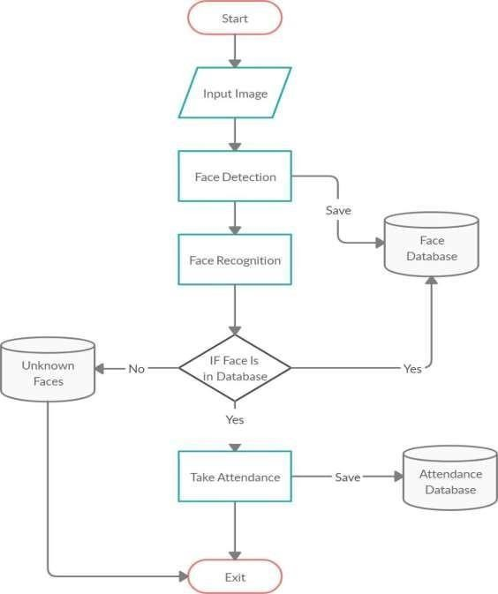

1. **ANNEXURE**
   1. **Sample Coding**

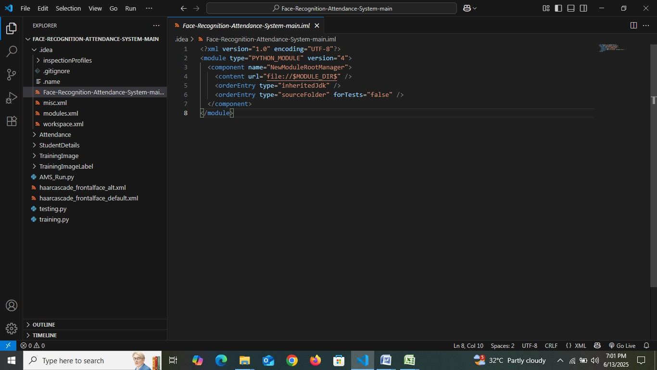

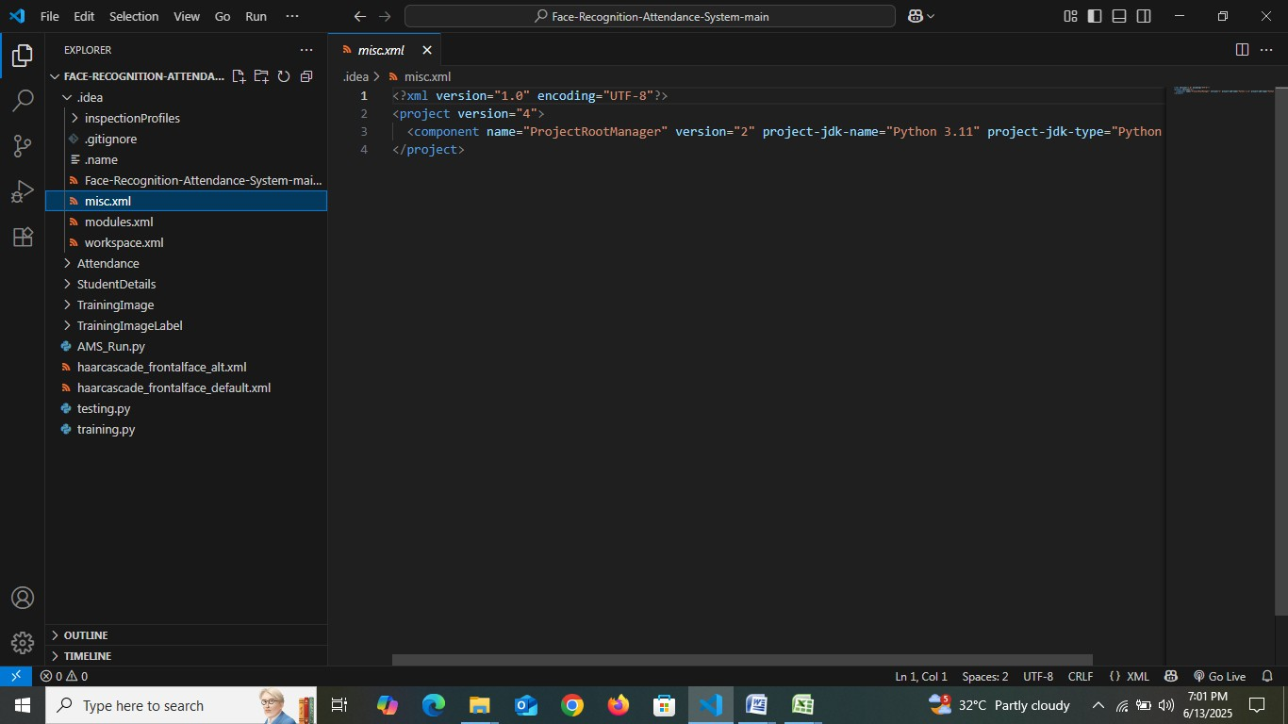

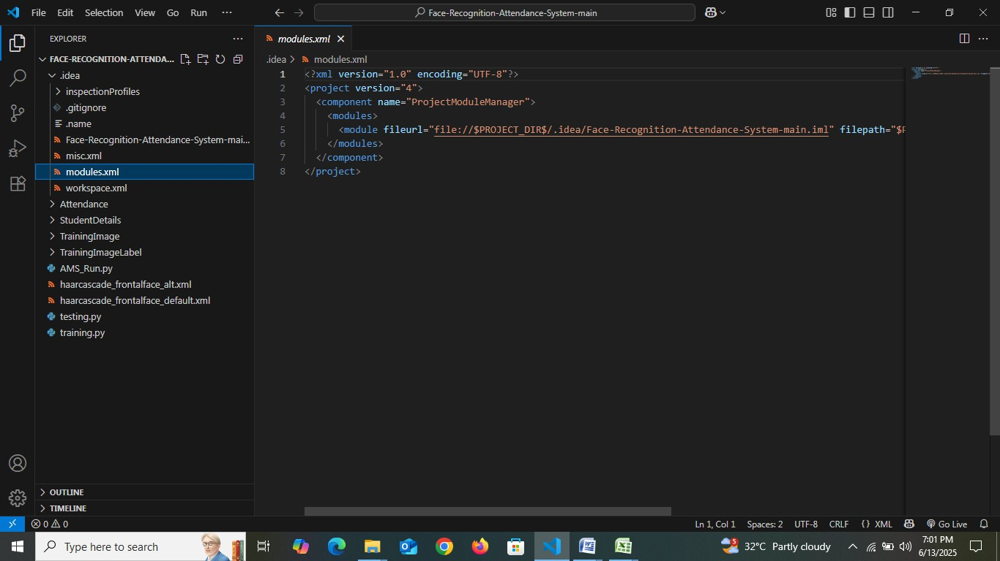

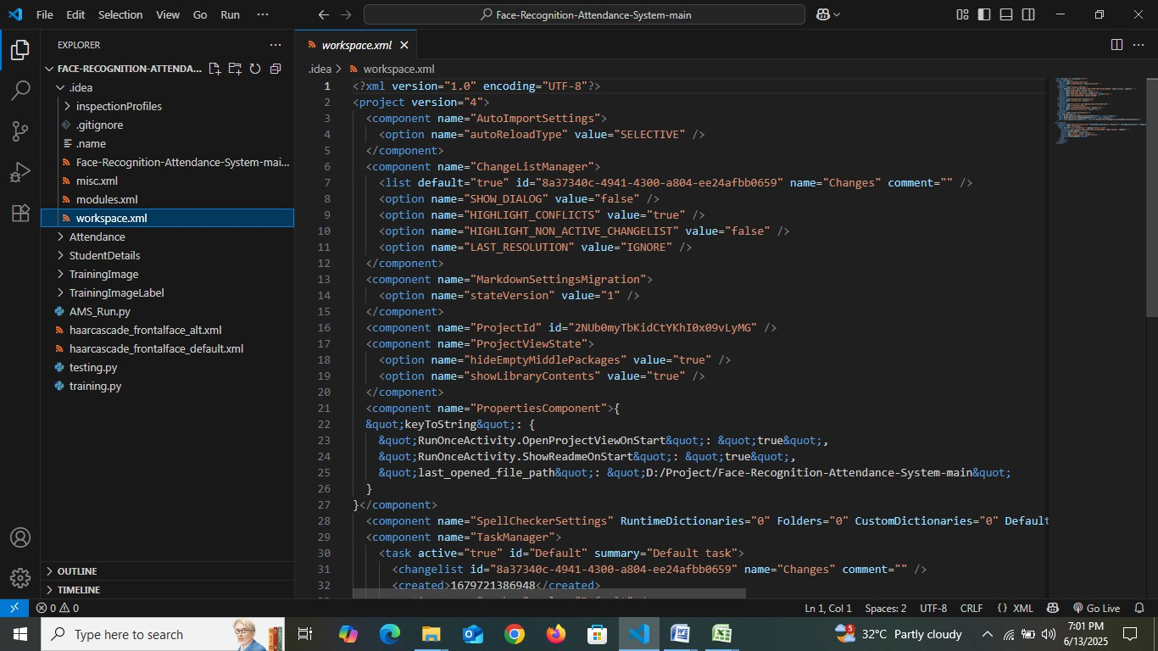

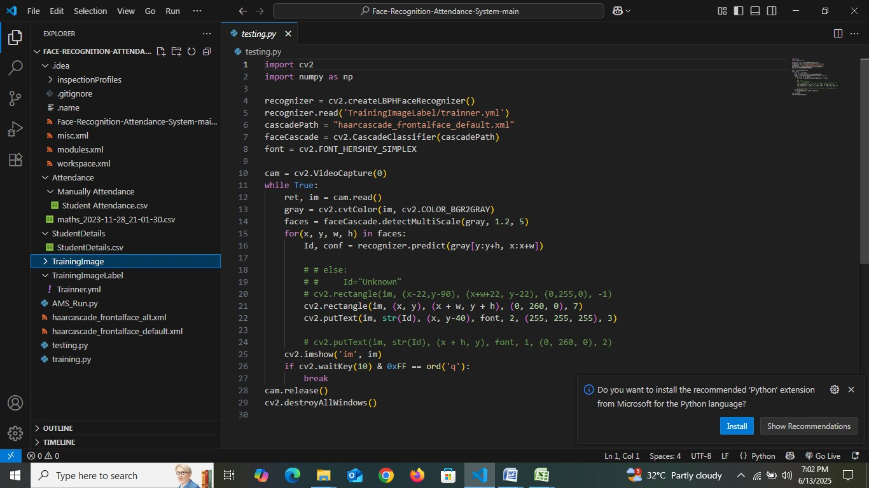

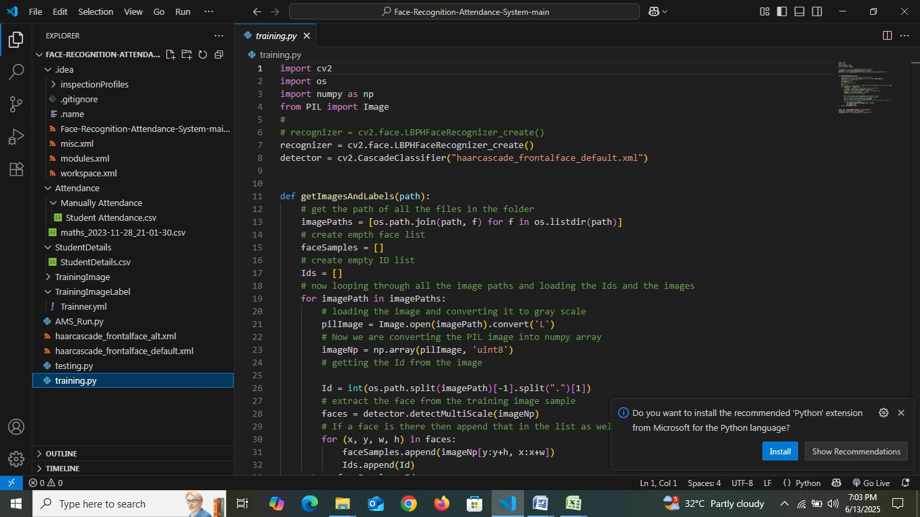

* 1. 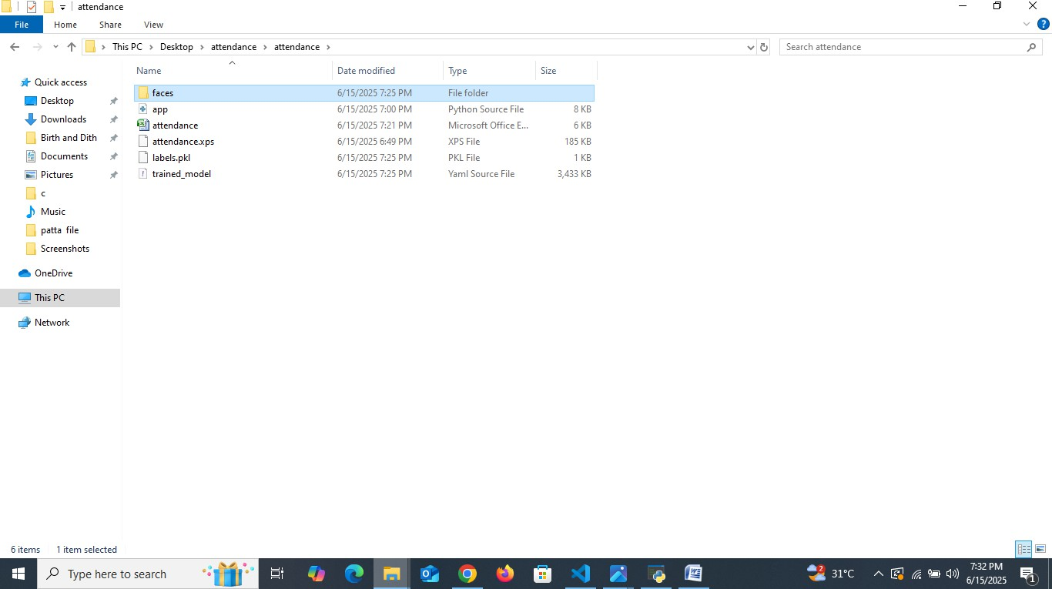**Sample 0utput File Directory**

**Main Frame**

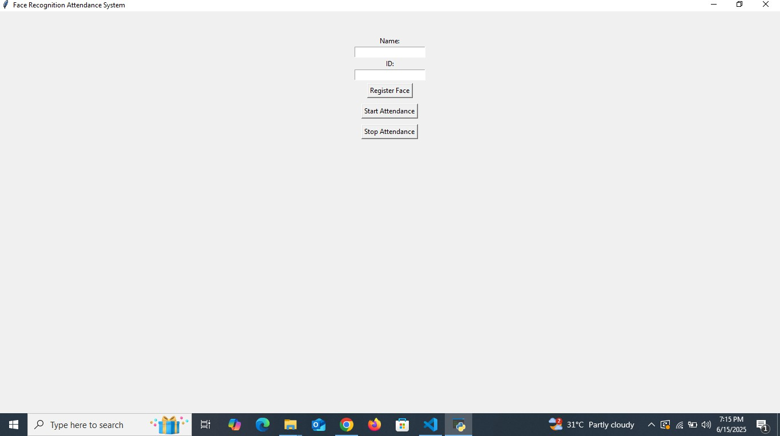

**User Input**

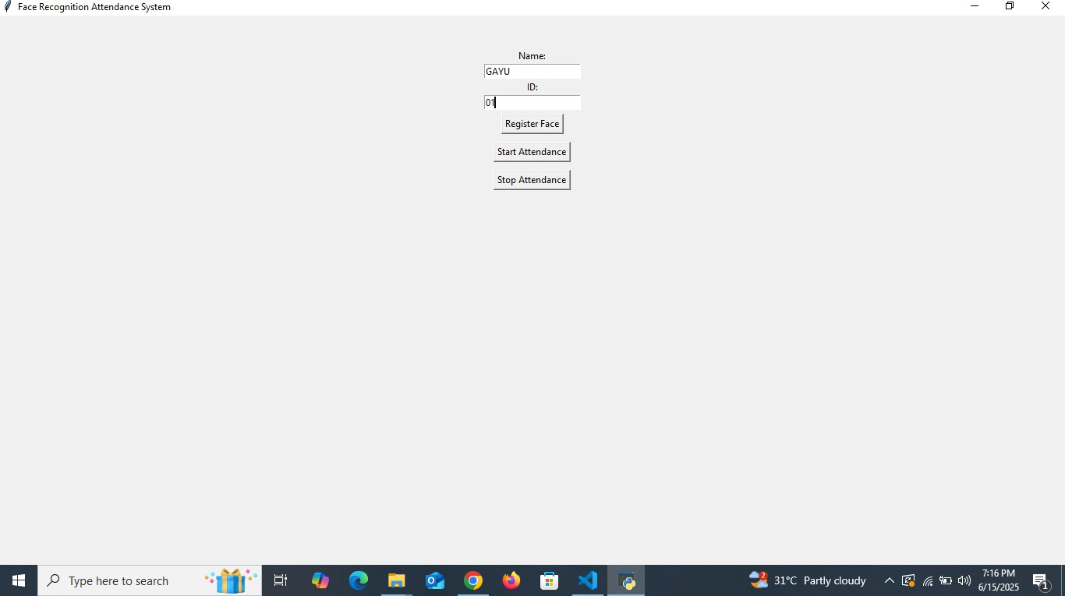

**Entering Name and ID**

**EXAMPLE:** NAME: GAYU ID: 01

**Register Face**

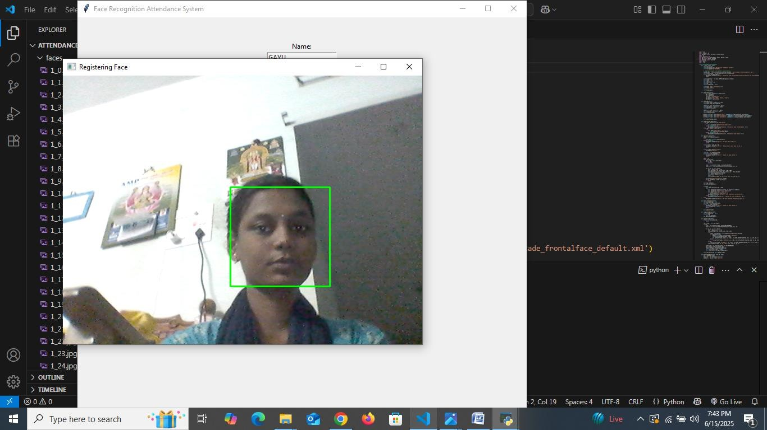

**Registering face of the Student**

**Success Message**

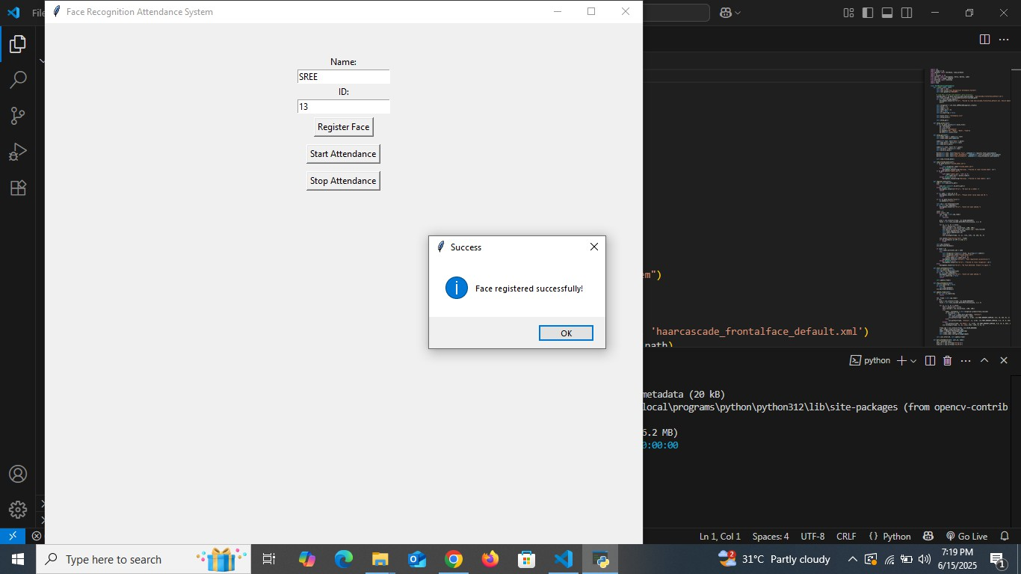

**Database**

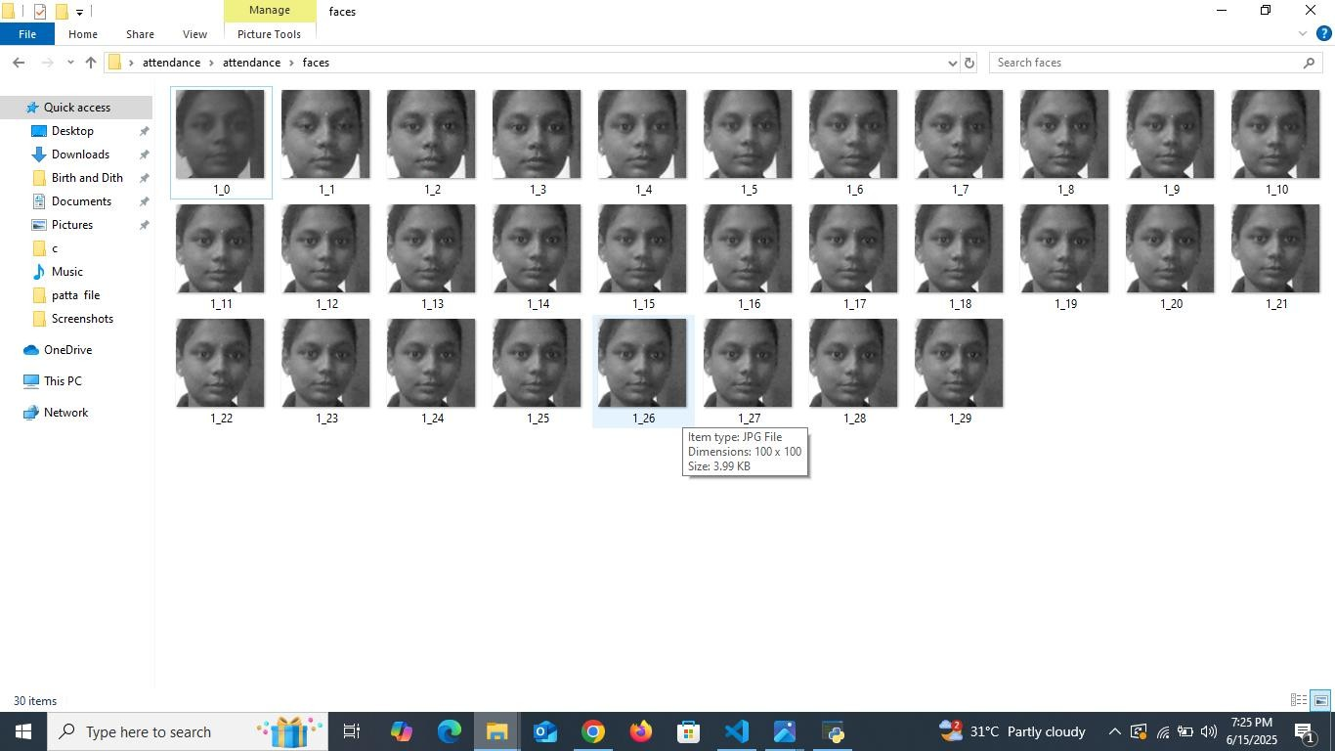

**Start Attendance**

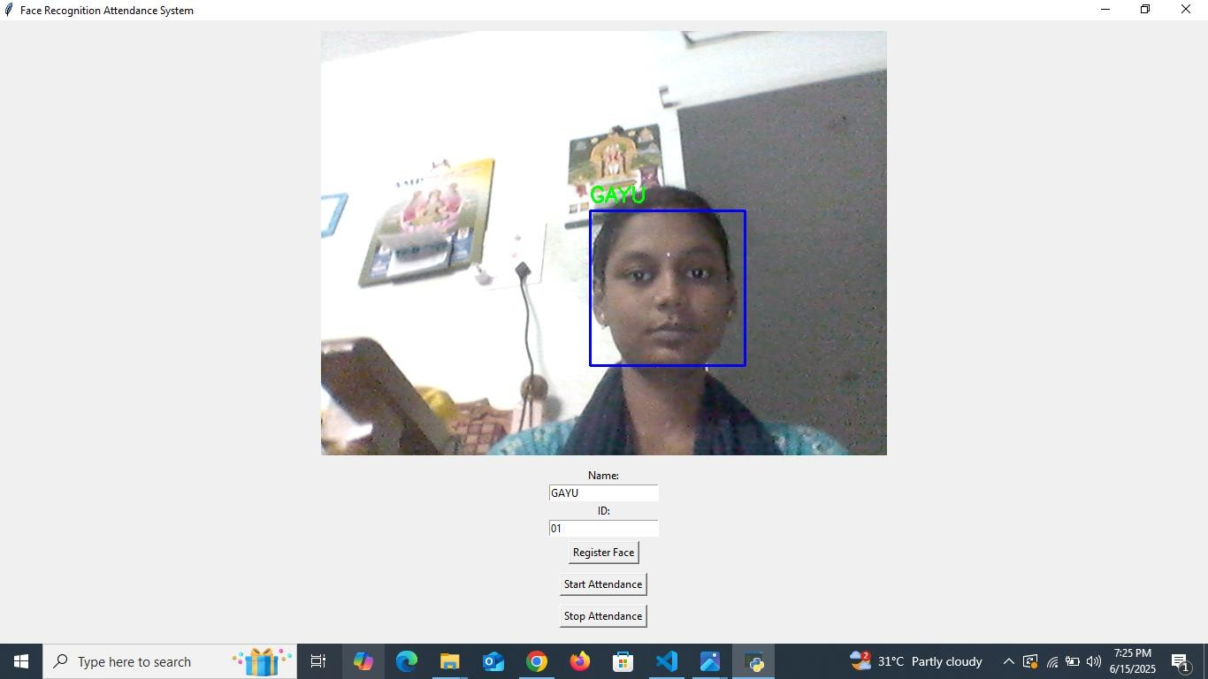

**Start Detecting the Registered Face**

### Additional Documents

**Project Progress Report (Reporting Period: Day 1 to Day 10)**

## Day 1: Project Planning and Environment Setup

* + - Gather and analyze project requirements
    - Research face recognition technology and tools
    - Set up the development environment and install necessary software

## Day 2: Library Research and Django Initialization

* + - Identify and choose suitable face recognition libraries
    - Initialize the Django project and configure basic settings

## Day 3: Database Design and Model Creation

* + - Design database schema for users and attendance data
    - Implement Django models reflecting the database structure

## Day 4: User Authentication Module

* + - Develop user registration and login functionalities
    - Create frontend templates for authentication pages

## Day 5: Face Recognition Integration

* + - Integrate face detection and recognition modules with backend
    - Test recognition using sample images and webcam

## Day 6: Attendance Functionality Development

* + - Implement attendance marking based on recognized faces
    - Connect attendance logic with the database

## Day 7: Dashboard and Reporting Features

* + - Build attendance dashboard for users and administrators
    - Add features to view, filter, and export attendance records

## Day 8: System Testing and Debugging

* + - Conduct thorough end-to-end testing
    - Identify and fix bugs and performance issues

## Day 9: Feature Enhancement and UI Refinement

* + - Add optional features like notifications or detailed reports
    - Improve UI design and responsiveness for better user experience

## Day 10: Documentation and Deployment

* + - Prepare comprehensive project documentation and user manual
    - Deploy the application on a local or cloud server
    - Perform final testing and submit the project